Available ERP Options
ERP system do the automation of back-end processes of an organization i.e. HR, Purchasing, Finance, CRM, property management etc.
A company can implement one of the three option for an ERP system:
- On the shelf system
- Exceed ERP
- Open Source ERP

On the shelf

Advantages of on the shelf ERP
- Matured for long time
Disadvantages of on the shelf
- Not flexible to modify features to suit customer need
- Not possible to add new features
- User based license—with increase in users increases license fee
On the shelf can be divided in to two:
- Tier 1for multi company big organizations/corporations
  - SAP
  - Oracle
Advantages
  - Can handle complex business rules
  - Very deep accounting segment to capture required insight in to transaction
  - Sophisticated business rules
Disadvantages
  - Costly license and implementation fee
  - Annual recurring payments
  - Support is mainly from abroad and expensive
- Small and Medium
  - Accpack-sage 300
  - Microsoft Dynamics
  - SAP small business
Advantages
  - Good for small and medium organizations
Disadvantages
  - Limited reporting capabilities
  - Limitations in flexibility

Open Source ERP
- Free of charge for the software
- But needs implementer which charges for the service
Advantages
  - No license fee
- Disadvantages
  - No dedicated company to take responsibility for the software
  - May change its direction of development

Exceed ERP System (Ours)

Developed by EXCEED IT Systems in Ethiopia for the last 7 years and implemented in many For large and small business.
Advantages
  - Developed with Ethiopian context
  - Easy to add new features based on customer need
  - No annual license fee
  - Close support and maintenance
  - Has implemented many of the concepts of tier 1 ERP systems

BI solutions

Aggregates data from all available systems including ERP system and generates different dashboards and reports to give top management an insight in to the business and make informed decisions. Example output from BI system is below.
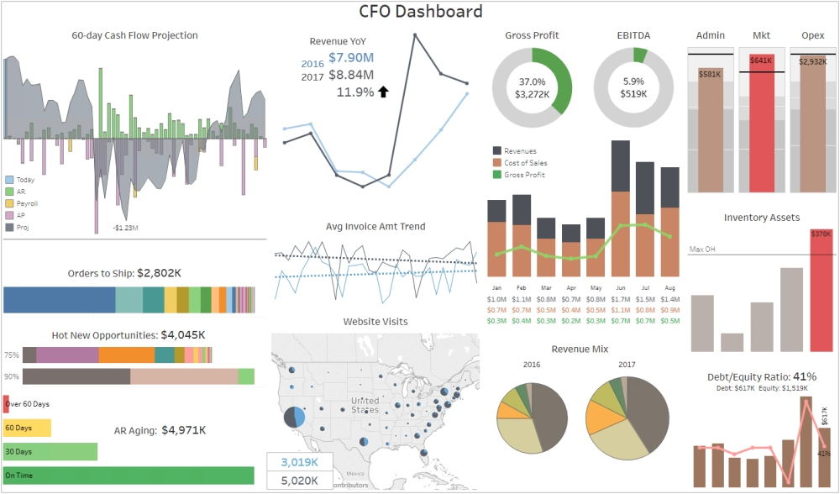

CRM

A CRM system manages the sales and marketing activities of an organization including customer care and handling.

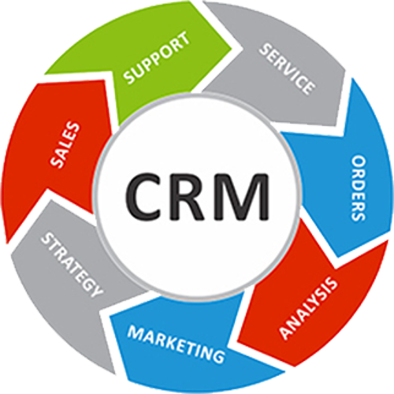

BSC

BSC system is s strategic management tool of a company. The system helps management and employees focus on the vision and strategies of the company and alarms them if the strategy is not being implemented the right way.

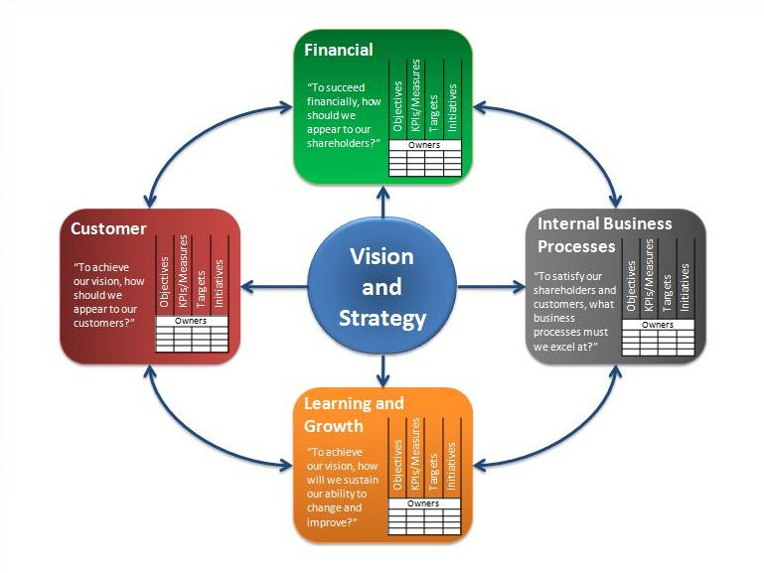

Estimated time to implement
- ERP 1 to 2 year
- BI 1 year
- CRM 6 months
- BSC 6 months
N.B. They can be done in parallel also

Estimated Budget
- ERP Tier 1 (SAP and Oracle) -up to 200M
- ERP others Average 2M

